Architecture Design

***HOSPITAL DATASET ANALYSIS***

|  |  |
| --- | --- |
| **Written By** | Aman Rajbhar |
| **Document Version** | 0.3 |
| **Last Revised Date** |  |

# DOCUMENT CONTROL

**Change Record:**

|  |  |  |  |
| --- | --- | --- | --- |
| **VERSION** | **DATE** | **AUTHOR** | **COMMENTS** |
| 0.1 | 28- AUG - 2024 | Aman Rajbhar | Introduction and architecture defined |
| 0.2 | 29 - AUG - 2024 | Aman Rajbhar | Architecture & Architecture description appended and updated. |
|  |  |  |  |

# Contents

## 1. Introduction………………………………………………………………………………………………………… 04

**1.1 What is Architecture Design Document? …………………………………………………. 04**

**1.2 Scope ……………………………………………………………………………………………………... 04**

## 2. Architecture ……………………………………………………………………………………………………….. 05

**2.1 Power BI Server Architecture…………………………….…………………….………………… 05**

**2.2 Gateway/Load Balancer ………………………………………………………………………… 06**

**2.3 Report Server ……………..…………………………………………………………………... 06**

**2.4 Data Source Integration ………..………………………………………………………………. 06**

**2.5 Data Modeling and DAX Engine .….…………………………………………………………. 06**

**2.6 Power BI Dataflows …………………….…………………………………………………………… 06**

**2.7 Power BI Communication Flow …………………………………………………………………. 07**

## 3. Deployment …………………………………………………………………………………………………………07

**3.1 Deployment Options in Power BI ……………………………………………………………….08**

**3.2 Single Node Architecture ………………………………………………………………………… 09**

**3.3 Three Node Architecture ………………………………………………………………………….10**

**3.4 Five Node Architecture …………………….………………………………………………………11**

# 1. Introduction

**1.1 What is Architecture design document?**

An Architecture Design Document explains how a system is built and how its different parts work together. In Power BI, this document shows how data is collected, analyzed, and turned into reports, including how the system handles data from start to finish.

Each style will describe a system category that consists of :

* A set of components (eg: a database, computational modules) that will perform a function required by the system.
* The set of connectors will help in coordination, communication, and cooperation between the components.
* Conditions that how components can be integrated to form the system.
* Semantic models that help the designer to understand the overall properties of the system.

## 1.2 Scope

This document explains how Power BI processes large amounts of data, including how Power BI Desktop, Power BI Service, and on-premises gateways work together to manage data, create reports, and share insights.

# 2. Architecture

Power BI is a tool used to turn raw data into visual reports and dashboards. It connects to many data sources and allows users to clean, model, and analyze data. Power BI can be used on the desktop (Power BI Desktop), online (Power BI Service), and on mobile devices.

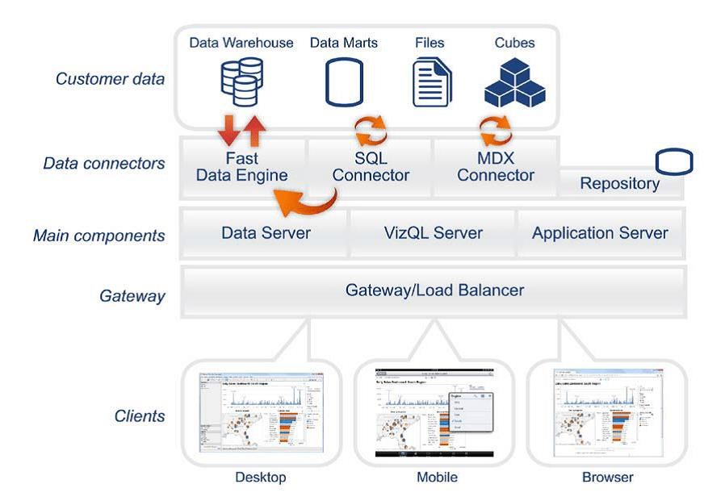

# 2.1 Power BI Server Architecture

Power BI Service is a cloud platform where reports are stored, shared, and accessed online. Users can collaborate, set up data refresh schedules, and share reports securely. It also allows real-time access to reports from any device.

The following diagram shows Power BI Server’s architecture:



Power BI Server is internally managed by the multiple server processes.

## 2.2 Gateway/Load Balancer

The Power BI Gateway connects your local data (like databases in your office) to Power BI Service in the

cloud. This allows you to refresh data and keep reports up-to-date without moving the data to the cloud.

The gateway ensures that your data stays secure during this process.

* 1. **Report Server :-**

Power BI Report Server lets you store Power BI reports on your company’s servers instead of the cloud. This is useful for companies that need more control over their data due to security or legal reasons.

* 1. **Data Source Integration:-**

Power BI can connect to many types of data, such as SQL databases, cloud platforms, or even Excel files. It can either **import** the data into its system or use **DirectQuery** to query data directly from its source in real-time.

* 1. **Data Modeling and DAX Engine:-**

Power BI allows users to create relationships between tables and perform calculations using DAX (Data Analysis Expressions), which is similar to Excel formulas but more powerful. This feature helps in building more advanced reports.

* 1. **Power BI Dataflows:-**

Power BI Dataflows help prepare data for multiple reports by cleaning and organizing it in one place. This saves time since you only need to prepare the data once, and it can be reused across multiple reports.

## 2.7 Power BI Communication Flow

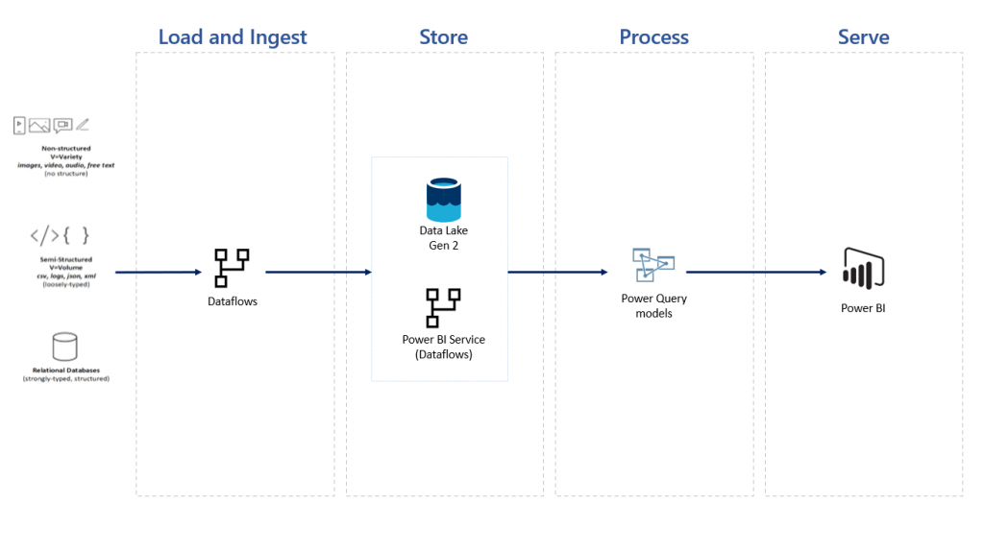

# 3. Deployment Description

## 3.1 Deployment options in Power BI

Power BI’s analytics platform offers three different deployment options depending on your environment and needs. The below graphic shows each option at a glance:

| **Power BI Service (Online)** | **Power BI on Public Cloud** | **Power BI Report Server (On-Premises)** |
| --- | --- | --- |
| Easy to use | Balanced | Customizable |
| Hosted on Microsoft Azure | AWS, GCP, or Azure | Local server (On-premises) |
| Subscription-based (Pro/Premium) | Fees for cloud server (Premium) | Hardware costs and upkeep |
| Configured by Microsoft | Your choice | Configured by You |

1. **Power BI Online**

* This is the easiest to use because it’s completely hosted by Microsoft on their Azure cloud platform.
* You don’t need to manage any infrastructure. You just need to subscribe to either the Pro or Premium version and start using it.
* Everything is handled by Microsoft, including setup and maintenance.

1. **Power BI on Public Cloud:**

* This option is more balanced because it allows you to host Power BI on different cloud services like AWS, Google Cloud, or Microsoft Azure.
* You’ll pay for using the cloud services, and you can choose the server that fits your needs.
* You get more flexibility, but you’ll need to manage some of the configurations yourself.

1. **Power BI Server deployed on-premises:**

* This is the most customizable option because you host Power BI on your company’s local servers (on-premises).
* You’ll have complete control but also have to pay for the hardware, maintenance, and updates.
* This option is usually configured by your own IT department, giving you maximum flexibility, but it requires more effort to manage..

## 3.2 Single Node Architecture

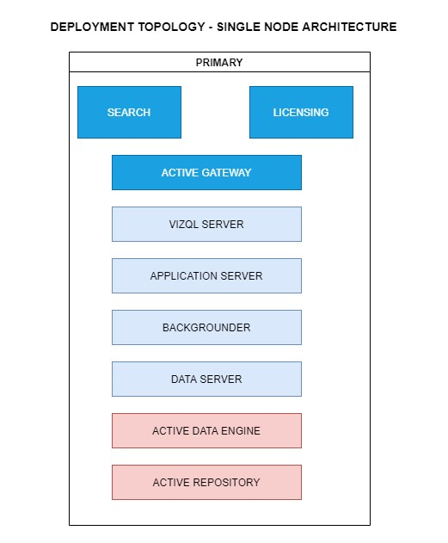

This architecture is a single node architecture. This is the most simple deployment topology.

## 3.3) 3 Node Architecture

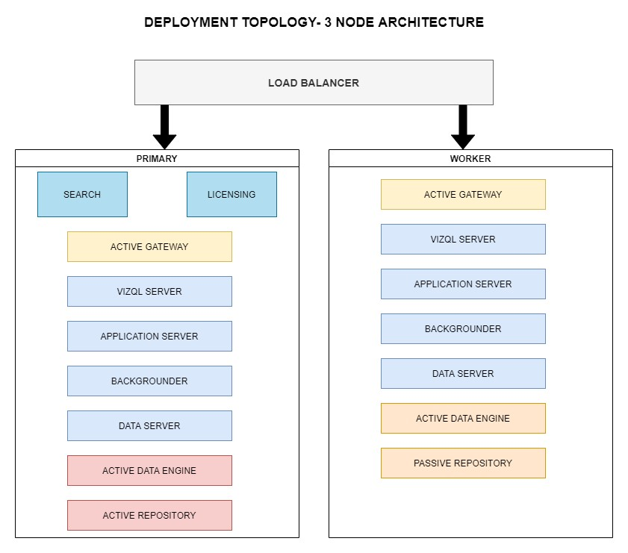

This architecture is a 3 Node Architecture which is more capable to handle concurrent requests.

If we need failover or high availability, or want a second instance of the repository, we must install Power BI Server on a cluster of at least three computers. In a cluster that includes at least three nodes, you can configure two instances of the repository, which gives our cluster failover capability.

## 3.4) 5 Node Architecture

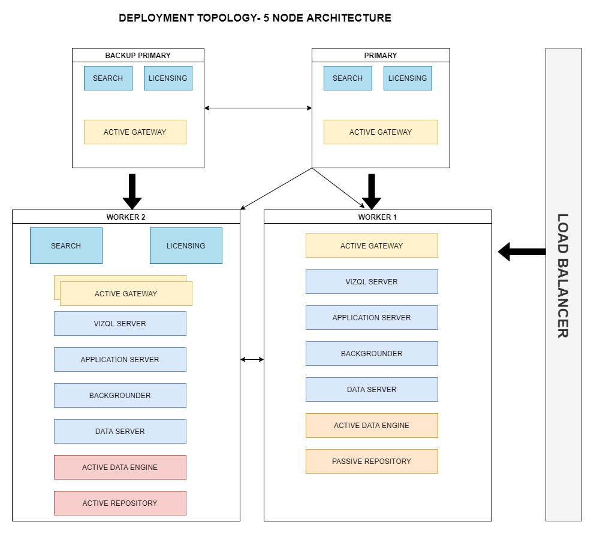

When we install Power BI Server on a Five-node cluster, we can install server processes on one or both nodes. A five-node cluster can improve the performance of Power BI Server, because the work is spread across multiple machines.

Note the following about five-node clusters:

* A five-node cluster does not provide failover or support for high availability.
* You can't install more than one instance of the repository on a two-node cluster, and the repository must be on the initial node.